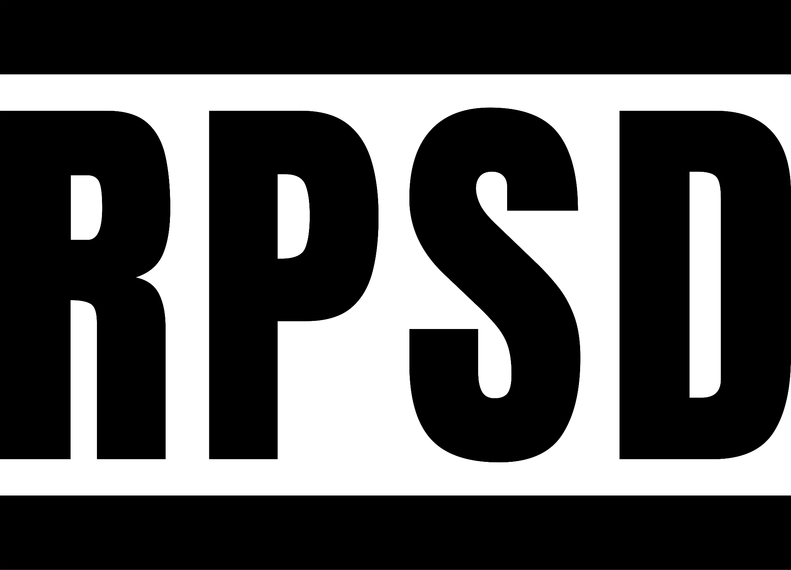

RPSD.earth
linktr.ee/ProjectRPSD

CREDITS

PART OF
MANDIN

FILMED AT
Atelier des Recycleurs Fous

MOULD DEVELOPMENT
Atelier des Recycleurs Fous
Easy Moulds
Open Source Skateboards
Plastic Odyssey

MUSIC
bokal - Beatfromabove
bokal - betablocker
bokal - lonnie
bokal - snørebånd

DKLG at Hart Lane Productions - Jase Beat 2
DKLG at Hart Lane Productions - Jase Beat 3
DKLG at Hart Lane Productions - Jase Beat 4
Hydroponics - Piano Beat
Hydroponics - Runnin' the Static

Jeff the Human - Umbrella Sellers

Muki Bu Mudiubi - Damalén balui thi bir
Muki Bu Mudiubi - Diax lé

örva - ab sorb it
örva - flat shapes
örva - flat shapes(am-edit)
örva - Ljus Fågel
örva - Poecilia reticulata

RilCx - Harakiri
RilCx - Mi Par D'udir Ancora

The Slag Brick Project - Elephant
The Slag Brick Project - Riverbed

